
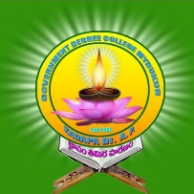

GOVT.DEGREE COLLEGE
MYDUKUR-516172
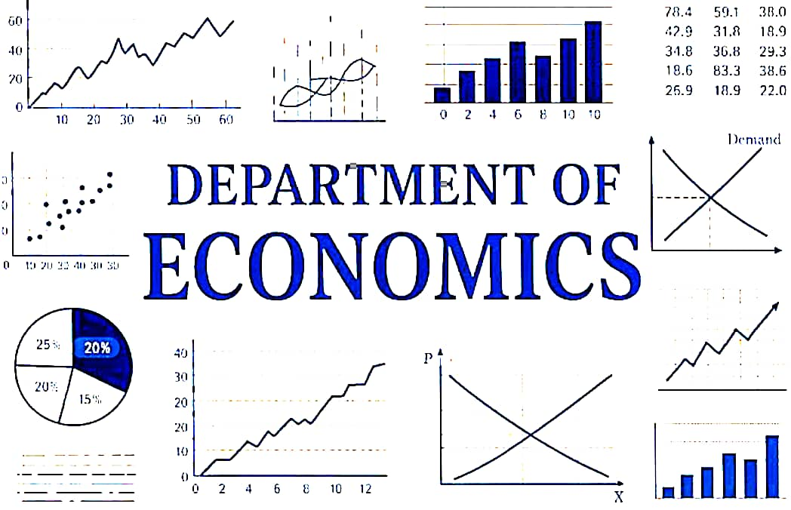

DEPARTMENT VISION & MISSIONS

ACADAMIC YEAR 2025--2026
NAME OF THE LECTURER: Dr.M.Sudheer Reddy

